Full Paper Template for Students’ Conference-2026

A. First¹, B. Second², and C. Third³
¹Department, Institution, City, State, Country
²Department, Institution, City, State, Country
³Department, Institution, City, State, Country
E-mail: Corresponding author’s email address

ABSTRACT: Instruction for the preparation of the full papers for the conference is presented. This template provides you with an example of the layout and style to follow during the preparation of your paper. The abstract should be a single paragraph (250 – 300 words long) written in plain language that includes a summary of the primary conclusions of the paper. Authors of papers to proceedings have to type these in a form suitable for electronic reproduction by the publisher. In order to ensure uniform style throughout the volume, all the papers have to be prepared strictly according to the instructions set below.

KEYWORDS: Geocell reinforcement, Composite model, Flexible pavements, and Parametric study.

1. INTRODUCTION
These are instructions for the preparation of full papers to be published in the e-proceeding of conference. Please follow the instructions carefully.

2. Instructions
2.1 Format
The paper should be prepared according to the instructions provided in this section. Use the formatting of this template for the titles, text, tables, figures, and equations of the paper.
Table 1. Editorial instructions
Item | Explanation
Paper size | Use A4 format (210 × 297 mm)
Length | Total number of paper should be 5-6 pages, though an overlength paper is also allowed
Margins | Leave 2 cm as margins on the top, 1.5 cm as margins on the bottom, and on the left and right sides
Fonts | Use bold 14-point Times New Roman font for the title; 10-point Times New Roman font for the authors; 9-point Times New Roman font in 1.0 line spacing for the text

2.1.1 Headings
All the headings should be in bold style. The first section headings should be in capital letters, and for the subsections, the first letter should be in uppercase, and the remaining letters should be in lowercase. Do not underline the headings. Section and subsection headings should be left-justified. After section headings and subsection headings, use 12 points or 1 line space.

2.1.2 Paragraphs
The first paragraph of each section needs no indentation.
Paragraphs after the first paragraph of each section need 1.5 characters of indentation at the first line. Leave no line space between the paragraphs.

2.1.3 Tables
The format of the tables is provided as presented in Table 1. The title of the letters for the table should be in bold. Their layout should be consistent throughout. Horizontal lines should be placed above and below label headings, below subheadings, and at the end of the table. Vertical lines should be avoided.

2.1.4 Figures
Figures and photographs must carry numbers in the text (e.g., Figure 1) and captions. Captions should be short and to the point; they do not need to include a complete explanation of the figure. The lettering of the caption should be nearly as large as the typeface used for the text. The title of the letters for the figure should be in bold. Every figure must have a figure number and be cited sequentially in the text.
Figures that are not legible when printing will be returned to the author for revision and will delay publication. Figures submitted in color will be published in color. Please note that the color figures provided must be suitable for printing in black and white.

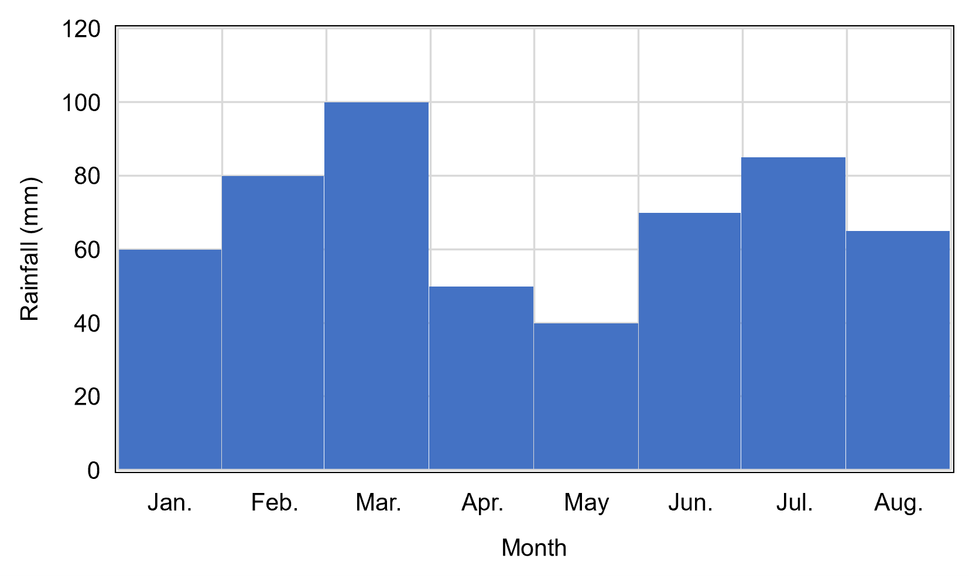
Figure 1. Insert figure caption here

2.1.5 Units
The use of the International System of Units (SI units) as the primary units of measure is mandatory. Other units of measurement may be given in parentheses after the SI unit if the author desires.

2.1.6 Equations
Equations should be confined to one line wherever possible, as in Eq. (1), and the equation editor should be used, for example in Eq. (1), or to align several equations. The equation should be kept at 12 points or 1.0 line space from above and underneath text lines.
$U = D\left({}_{1}, {}_{2}, _{3}\right)×R_{12}(a, {}_{4})$ (1)

3. CONCLUSIONS
At the end of the manuscript text, authors must include a set of conclusions or summaries, in which the significant implications of the information presented in the body of the text are reviewed.

4. ACKNOWLEDGMENTS
Acknowledgments are encouraged as a way to thank those who have contributed to the research or project but did not merit being listed as an author. Authors can include an acknowledgment section to recognize any advisory or financial help received.

5. REFERENCES
The author-date method for in-text references (e.g., Chao, 2018 or Nelson and Chao, 2022) is used for our journal. A reference section must be included that lists all references alphabetically by the last name of the first author. References cited in text that are not found in the reference list will be deleted. Likewise, all references included in the reference section must be cited in the text. Examples of reference formatting are provided below.

Bian, J., Gu, Y., and Murray, M. H. (2013). A Dynamic Wheel-Rail Impact Analysis of Railway Track Under Wheel Flat by Finite Element Analysis. International Journal of Vehicle System Dynamics, Taylor & Francis Group, 51(6), 784-797.
Chao, K. C., Overton, D. D., and Nelson, J. D. (2006). Design and Installation of Deep Benchmarks in Expansive Soil. Journal of Surveying Engineering, American Society of Civil Engineers, 132(3), 124-131.
Malviya, S., & Raychowdhury, P. (2025). Seismic analysis of geogrid-reinforced MSE walls with pond ash backfill. International Journal of Geotechnical Engineering, 19(10), 997-1015.
Nelson, J. D., Chao, K. C., Overton, D. D., and Nelson, E. J. (2015). Foundation Engineering for Expansive Soils. John Wiley & Sons, Inc., New York, NY.

